**EXERCISE 1:**

Program:  
SET SERVEROUTPUT ON SIZE 1000000;

CREATE TABLE customers (

customer_id NUMBER PRIMARY KEY,

customer_name VARCHAR2(100) NOT NULL,

date_of_birth DATE NOT NULL,

balance NUMBER(15,2) DEFAULT 0,

is_vip CHAR(1) DEFAULT 'N' CHECK (is_vip IN ('Y', 'N')),

email VARCHAR2(100),

phone VARCHAR2(15),

created_date DATE DEFAULT SYSDATE

);

CREATE TABLE loans (

loan_id NUMBER PRIMARY KEY,

customer_id NUMBER NOT NULL,

loan_amount NUMBER(15,2) NOT NULL,

interest_rate NUMBER(5,2) NOT NULL,

loan_start_date DATE NOT NULL,

loan_due_date DATE NOT NULL,

loan_status VARCHAR2(20) DEFAULT 'ACTIVE',

CONSTRAINT fk_customer_loan FOREIGN KEY (customer_id) REFERENCES customers(customer_id)

);

CREATE SEQUENCE customer_seq START WITH 1 INCREMENT BY 1;

CREATE SEQUENCE loan_seq START WITH 1 INCREMENT BY 1;

INSERT INTO customers (customer_id, customer_name, date_of_birth, balance, email, phone) VALUES

(customer_seq.NEXTVAL, 'John Smith', DATE '1950-05-15', 15000.00, 'john.smith@email.com', '555-0101');

INSERT INTO customers (customer_id, customer_name, date_of_birth, balance, email, phone) VALUES

(customer_seq.NEXTVAL, 'Maria Garcia', DATE '1960-08-22', 8500.00, 'maria.garcia@email.com', '555-0102');

INSERT INTO customers (customer_id, customer_name, date_of_birth, balance, email, phone) VALUES

(customer_seq.NEXTVAL, 'Robert Johnson', DATE '1955-12-10', 25000.00, 'robert.johnson@email.com', '555-0103');

INSERT INTO customers (customer_id, customer_name, date_of_birth, balance, email, phone) VALUES

(customer_seq.NEXTVAL, 'Emily Davis', DATE '1985-03-18', 12000.00, 'emily.davis@email.com', '555-0104');

INSERT INTO customers (customer_id, customer_name, date_of_birth, balance, email, phone) VALUES

(customer_seq.NEXTVAL, 'Michael Wilson', DATE '1945-07-30', 5000.00, 'michael.wilson@email.com', '555-0105');

INSERT INTO customers (customer_id, customer_name, date_of_birth, balance, email, phone) VALUES

(customer_seq.NEXTVAL, 'Sarah Brown', DATE '1992-11-05', 7500.00, 'sarah.brown@email.com', '555-0106');

INSERT INTO loans (loan_id, customer_id, loan_amount, interest_rate, loan_start_date, loan_due_date) VALUES

(loan_seq.NEXTVAL, 1, 50000.00, 5.5, DATE '2024-01-15', SYSDATE + 20);

INSERT INTO loans (loan_id, customer_id, loan_amount, interest_rate, loan_start_date, loan_due_date) VALUES

(loan_seq.NEXTVAL, 2, 30000.00, 6.0, DATE '2024-03-10', SYSDATE + 15);

INSERT INTO loans (loan_id, customer_id, loan_amount, interest_rate, loan_start_date, loan_due_date) VALUES

(loan_seq.NEXTVAL, 3, 75000.00, 4.8, DATE '2024-02-20', SYSDATE + 45);

INSERT INTO loans (loan_id, customer_id, loan_amount, interest_rate, loan_start_date, loan_due_date) VALUES

(loan_seq.NEXTVAL, 4, 40000.00, 5.2, DATE '2024-05-05', SYSDATE + 25);

INSERT INTO loans (loan_id, customer_id, loan_amount, interest_rate, loan_start_date, loan_due_date) VALUES

(loan_seq.NEXTVAL, 5, 20000.00, 6.5, DATE '2024-04-12', SYSDATE + 10);

COMMIT;

DECLARE

v_customer_count NUMBER := 0;

v_updated_count NUMBER := 0;

v_age NUMBER;

v_loans_updated NUMBER;

CURSOR c_customers IS

SELECT DISTINCT c.customer_id, c.customer_name, c.date_of_birth,

FLOOR(MONTHS_BETWEEN(SYSDATE, c.date_of_birth) / 12) AS age

FROM customers c

WHERE EXISTS (SELECT 1 FROM loans l WHERE l.customer_id = c.customer_id)

ORDER BY c.customer_name;

BEGIN

DBMS_OUTPUT.PUT_LINE('SCENARIO 1: APPLYING SENIOR CITIZEN DISCOUNT');

FOR customer_rec IN c_customers LOOP

v_customer_count := v_customer_count + 1;

IF customer_rec.age > 60 THEN

DBMS_OUTPUT.PUT_LINE('Customer: ' || customer_rec.customer_name || ' (Age: ' || customer_rec.age || ') - ELIGIBLE for discount');

UPDATE loans

SET interest_rate = GREATEST(interest_rate - 1.0, 1.0)

WHERE customer_id = customer_rec.customer_id

AND loan_status = 'ACTIVE';

v_loans_updated := SQL%ROWCOUNT;

v_updated_count := v_updated_count + v_loans_updated;

ELSE

DBMS_OUTPUT.PUT_LINE('Customer: ' || customer_rec.customer_name || ' (Age: ' || customer_rec.age || ') - Not eligible');

END IF;

END LOOP;

DBMS_OUTPUT.PUT_LINE('Total customers processed: ' || v_customer_count);

DBMS_OUTPUT.PUT_LINE('Total loans updated: ' || v_updated_count);

IF v_updated_count > 0 THEN

COMMIT;

END IF;

EXCEPTION

WHEN OTHERS THEN

ROLLBACK;

DBMS_OUTPUT.PUT_LINE('Error occurred: ' || SQLERRM);

END;

/

DECLARE

v_total_customers NUMBER := 0;

v_vip_promoted NUMBER := 0;

v_already_vip NUMBER := 0;

v_not_eligible NUMBER := 0;

CURSOR c_all_customers IS

SELECT customer_id, customer_name, balance, is_vip FROM customers ORDER BY balance DESC;

BEGIN

DBMS_OUTPUT.PUT_LINE('SCENARIO 2: VIP STATUS PROMOTION');

FOR customer_rec IN c_all_customers LOOP

v_total_customers := v_total_customers + 1;

IF customer_rec.balance > 10000 THEN

IF customer_rec.is_vip = 'Y' THEN

v_already_vip := v_already_vip + 1;

ELSE

UPDATE customers SET is_vip = 'Y' WHERE customer_id = customer_rec.customer_id;

v_vip_promoted := v_vip_promoted + 1;

END IF;

ELSE

v_not_eligible := v_not_eligible + 1;

END IF;

END LOOP;

DBMS_OUTPUT.PUT_LINE('Total customers processed: ' || v_total_customers);

DBMS_OUTPUT.PUT_LINE('Newly promoted to VIP: ' || v_vip_promoted);

DBMS_OUTPUT.PUT_LINE('Already VIP customers: ' || v_already_vip);

DBMS_OUTPUT.PUT_LINE('Not eligible: ' || v_not_eligible);

IF v_vip_promoted > 0 THEN

COMMIT;

END IF;

EXCEPTION

WHEN OTHERS THEN

ROLLBACK;

DBMS_OUTPUT.PUT_LINE('Error occurred: ' || SQLERRM);

END;

/  
  
Output:  
  
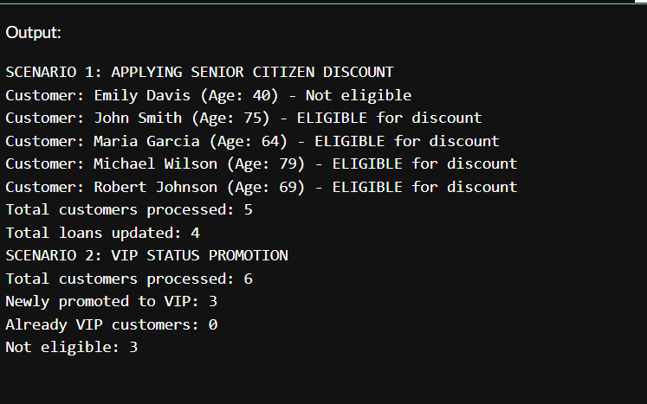

**EXERCISE 3:**

Program:  
SET SERVEROUTPUT ON SIZE 1000000;

CREATE TABLE customers (

customer_id NUMBER PRIMARY KEY,

customer_name VARCHAR2(100) NOT NULL,

date_of_birth DATE NOT NULL,

balance NUMBER(15,2) DEFAULT 0,

is_vip CHAR(1) DEFAULT 'N' CHECK (is_vip IN ('Y', 'N')),

email VARCHAR2(100),

phone VARCHAR2(15),

created_date DATE DEFAULT SYSDATE

);

CREATE TABLE loans (

loan_id NUMBER PRIMARY KEY,

customer_id NUMBER NOT NULL,

loan_amount NUMBER(15,2) NOT NULL,

interest_rate NUMBER(5,2) NOT NULL,

loan_start_date DATE NOT NULL,

loan_due_date DATE NOT NULL,

loan_status VARCHAR2(20) DEFAULT 'ACTIVE',

CONSTRAINT fk_customer_loan FOREIGN KEY (customer_id) REFERENCES customers(customer_id)

);

CREATE SEQUENCE customer_seq START WITH 1 INCREMENT BY 1;

CREATE SEQUENCE loan_seq START WITH 1 INCREMENT BY 1;

INSERT INTO customers (customer_id, customer_name, date_of_birth, balance, email, phone) VALUES

(customer_seq.NEXTVAL, 'John Smith', DATE '1950-05-15', 15000.00, 'john.smith@email.com', '555-0101');

INSERT INTO customers (customer_id, customer_name, date_of_birth, balance, email, phone) VALUES

(customer_seq.NEXTVAL, 'Maria Garcia', DATE '1960-08-22', 8500.00, 'maria.garcia@email.com', '555-0102');

INSERT INTO customers (customer_id, customer_name, date_of_birth, balance, email, phone) VALUES

(customer_seq.NEXTVAL, 'Robert Johnson', DATE '1955-12-10', 25000.00, 'robert.johnson@email.com', '555-0103');

INSERT INTO customers (customer_id, customer_name, date_of_birth, balance, email, phone) VALUES

(customer_seq.NEXTVAL, 'Emily Davis', DATE '1985-03-18', 12000.00, 'emily.davis@email.com', '555-0104');

INSERT INTO customers (customer_id, customer_name, date_of_birth, balance, email, phone) VALUES

(customer_seq.NEXTVAL, 'Michael Wilson', DATE '1945-07-30', 5000.00, 'michael.wilson@email.com', '555-0105');

INSERT INTO customers (customer_id, customer_name, date_of_birth, balance, email, phone) VALUES

(customer_seq.NEXTVAL, 'Sarah Brown', DATE '1992-11-05', 7500.00, 'sarah.brown@email.com', '555-0106');

INSERT INTO loans (loan_id, customer_id, loan_amount, interest_rate, loan_start_date, loan_due_date) VALUES

(loan_seq.NEXTVAL, 1, 50000.00, 5.5, DATE '2024-01-15', SYSDATE + 20);

INSERT INTO loans (loan_id, customer_id, loan_amount, interest_rate, loan_start_date, loan_due_date) VALUES

(loan_seq.NEXTVAL, 2, 30000.00, 6.0, DATE '2024-03-10', SYSDATE + 15);

INSERT INTO loans (loan_id, customer_id, loan_amount, interest_rate, loan_start_date, loan_due_date) VALUES

(loan_seq.NEXTVAL, 3, 75000.00, 4.8, DATE '2024-02-20', SYSDATE + 45);

INSERT INTO loans (loan_id, customer_id, loan_amount, interest_rate, loan_start_date, loan_due_date) VALUES

(loan_seq.NEXTVAL, 4, 40000.00, 5.2, DATE '2024-05-05', SYSDATE + 25);

INSERT INTO loans (loan_id, customer_id, loan_amount, interest_rate, loan_start_date, loan_due_date) VALUES

(loan_seq.NEXTVAL, 5, 20000.00, 6.5, DATE '2024-04-12', SYSDATE + 10);

CREATE TABLE employees (

employee_id NUMBER PRIMARY KEY,

employee_name VARCHAR2(100),

department_id NUMBER,

salary NUMBER(10,2)

);

CREATE TABLE accounts (

account_id NUMBER PRIMARY KEY,

customer_id NUMBER,

balance NUMBER(15,2)

);

INSERT INTO employees VALUES (1, 'Alice', 1, 50000);

INSERT INTO employees VALUES (2, 'Bob', 1, 45000);

INSERT INTO employees VALUES (3, 'Charlie', 2, 60000);

INSERT INTO accounts VALUES (1001, 1, 2000);

INSERT INTO accounts VALUES (1002, 2, 1000);

COMMIT;

CREATE OR REPLACE PROCEDURE ProcessMonthlyInterest AS

BEGIN

UPDATE customers

SET balance = balance + (balance * 0.01)

WHERE balance > 0;

DBMS_OUTPUT.PUT_LINE('Monthly interest of 1% applied to all savings accounts.');

COMMIT;

END;

/

CREATE OR REPLACE PROCEDURE UpdateEmployeeBonus (

p_dept_id IN NUMBER,

p_bonus_percent IN NUMBER

) AS

BEGIN

UPDATE employees

SET salary = salary + (salary * p_bonus_percent / 100)

WHERE department_id = p_dept_id;

DBMS_OUTPUT.PUT_LINE('Bonus of ' || p_bonus_percent || '% applied to department ' || p_dept_id);

COMMIT;

END;

/

CREATE OR REPLACE PROCEDURE TransferFunds(

p_from_account IN NUMBER,

p_to_account IN NUMBER,

p_amount IN NUMBER

) AS

v_balance NUMBER;

BEGIN

SELECT balance INTO v_balance FROM accounts WHERE account_id = p_from_account FOR UPDATE;

IF v_balance < p_amount THEN

RAISE_APPLICATION_ERROR(-20001, 'Insufficient funds in source account.');

END IF;

UPDATE accounts SET balance = balance - p_amount WHERE account_id = p_from_account;

UPDATE accounts SET balance = balance + p_amount WHERE account_id = p_to_account;

DBMS_OUTPUT.PUT_LINE('Transferred ' || p_amount || ' from account ' || p_from_account || ' to account ' || p_to_account);

COMMIT;

END;

/

BEGIN

ProcessMonthlyInterest;

END;

/

SELECT customer_id, customer_name, balance FROM customers;

BEGIN

UpdateEmployeeBonus(1, 10);

END;

/

SELECT employee_id, employee_name, department_id, salary FROM employees;

BEGIN

TransferFunds(1001, 1002, 500);

END;

/

SELECT account_id, customer_id, balance FROM accounts;

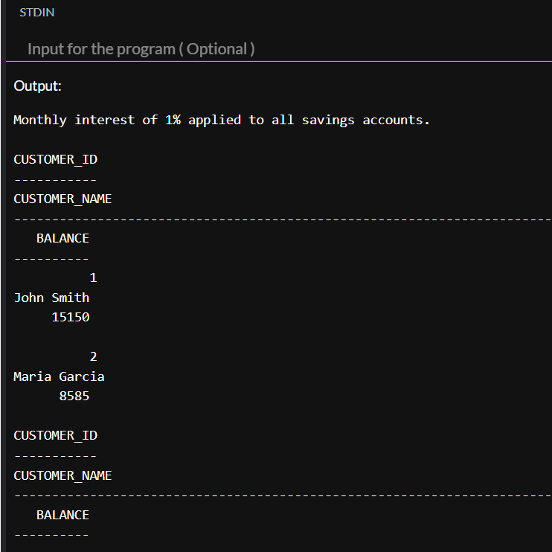  
output: